***NoSQL Database for Implementing E-commerce Application***

*Submitted by*

***Rohit Pandey***

***(Regd No.:21352046)***

*M.C.A (3rd Semester)*

***Project Report***

*Submitted in partial fulfilment of the requirements for the award of the degree for the Master of Computer Applications*

*Under the guidance of*

***Dr. Pothula Sujatha***

*(Associate Professor)*



***DEPARTMENT OF COMPUTER SCIENCE***

***SCHOOL OF ENGINEERING AND TECHNOLOGY***

***PONDICHERRY UNIVERSITY***

***PUDUCHERRY- 605014***

***November 2022***

***BONAFIDE CERTIFICATE***

*This is to certify that the project work entitled* ***“NoSQL Database for Implementing E-commerce Application”*** *a bonafide record of work done by* ***Rohit Pandey, Reg. No.: 21352046*** *in partial fulfilment for the award degree of Master of Computer Applications in department of computer science, school of engineering and technology, Pondicherry University.*

*This work has not been submitted elsewhere for the award of any degree of the best of our knowledge.*

*___________________________________*

*Head Of The Department*

***Dr. S Sivasathya***

*(Professor) &*

*Head Department of Computer Science,*

*School of Engineering & Technology,*

*Pondicherry University, Pondicherry*

*____________________________________*

*Signature of the guide*

***Dr. Pothula Sujatha***

*(Associate Professor)*

*Department of Computer Science,*

*School of Engineering & Technology,*

*Pondicherry University, Pondicherry*

*Submitted on ________________*

***ACKNOWLEGMENT***

*The Satisfaction that accompanies the successful completion of any task would be incomplete without mentioning about those who made it possible, whose constant guidance and encouragement has crowned the efforts with success.*

*First and foremost, I thank the Almighty God for being with me over the years and guiding me to the heights of success. I extend sincere gratitude to my parents for their love, care and support.*

*I would like to express my sincere gratitude to* ***Dr. R.P SEENIVASAN*** *(Associate Professor, Pondicherry University), Project Coordinator for their timely checking up for the progress of my project and in turn encouraging me to complete in time with his valuable piece of advice, He has been constant source of inspiration throughout course.*

*I would like to express mu sincere gratitude to my guide* ***Dr. Pothula Sujatha*** *(Associate Professor, Pondicherry University), for her tremendous support, guidance and valuable suggestions thought the course of this project. She has always been my constant source of inspiration and motivation. Without her encouragement and guidance this project would not have materialized.*

*The guidance and support received from the Department of Computer science was vital for the success of the project. I am grateful for their constant support and help.*

***ROHIT PANDEY***

***TABLE OF CONTENTS***

|  |  |  |
| --- | --- | --- |
|  |  | ***Page No.*** |
| ***Chapter 1*** | ***Introduction*** | ***4 – 8*** |
|  | *1.1 Abstract* | *4 – 4* |
|  | *1.2 About the project* | *5 – 5* |
|  | *1.3 Statement of the problem* | *6 – 6* |
|  | *1.4 The solution* | *6 – 6* |
|  | *1.5 Aims and objectives* | *6 – 7* |
|  | *1.6 Importance of online shopping* | *7 – 7* |
|  | *1.7 Problem of online shopping* | *7 – 7* |
|  | *1.8 Privacy and security in online shopping* | *7 – 8* |
|  |  |  |
| ***Chapter 2*** | ***Project Description & Analysis*** | ***9 – 11*** |
|  | *2.1 Project analysis* | *9 – 10* |
|  | *2.2 System analysis* | *10 – 10* |
|  | *2.3 Hardware requirements* | *10 – 10* |
|  | *2.4 Software requirements* | *10 – 10* |
|  | *2.5 System requirements* | *10 – 10* |
|  |  |  |
| ***Chapter 3*** | ***System Design*** | ***11 – 16*** |
|  | *3.1 Process flow diagram* | *11 – 12* |
|  | *3.2 Data flow diagram* | *12 – 13* |
|  | *3.3 Flow chart diagram* | *14 – 14* |
|  | *3.4 UML diagram* | *15 – 15* |
|  | *3.5 Data design* | *16 – 16* |
|  | *3.6 Data relationship* | *16 – 16* |
|  |  |  |
| ***Chapter 4*** | ***Conclusion Recommendation*** | ***17 – 18*** |
|  | *4.1 Conclusion* | *17 – 17* |
|  | *4.2 Recommendation* | *17 – 17* |
|  | *4.3 Record of all procedure* | *17 – 18* |
|  | *4.4 structure of the project file* | *18 – 18* |
|  |  |  |
| ***References*** |  | *19* |

***Chapter 1 - Introduction***

* 1. ***Abstract***

*E-Commerce (Electronic Commerce) is process of doing business through computer networks. A person sitting on his chair in front of a computer can access all the facilities of the Internet to buy or sell the products. Unlike traditional commerce that is carried out physically with effort of a person to go and get products, e-commerce has made it easier for human to reduce physical work and to save time.    E-Commerce which was started in early 1990’s has taken a great leap in the world of computers, but the fact that has hindered the growth of e-commerce is security. Security is the challenge facing e-commerce today & there is still a lot of advancement made in the field of security.*

*The project objective is to deliver the online shopping application. This project is an attempt to provide the advantages of online shopping to customers of a real shop. It helps buying the products in the shop anywhere through internet by using a web site. Thus the customer will get the service of online shopping and home delivery from this shop. This system can be implemented to Sai Supermarket in the locality. If shops are providing an online portal where their customers can enjoy easy shopping from anywhere, the shops won’t be losing any more customers to the trending online shops such as flipkart or eBay. Since the application is available in the given site it is easily accessible and always available.*

* 1. ***About the project***

*E-commerce is a term for any type of business, or commercial transaction that involves the transfer of information across the Internet. It covers a range of different types of businesses, from consumer based retail sites, through auction or music sites, to business exchanges trading goods and services between corporations. It is currently one of the most important aspects of the Internet to emerge. There are six types of E-commerce website. The e-commerce sector is seen the exponential growth thus a new option will easily part of this regatta of commercial website. The e-commerce website will feature the online shopping facility of various fashion products under a single web space. The proposed web application will allow business personnel to make their total business using it and increase their reachability thousands of times more than today they have, over the internet. It will allow multiple shopping vendors to sale their products online. The product management in the system will be done in the form of categories. The safety of information is the main requirement of the system and will be handling according to that. To formulate this project first task is to do is cost estimation. For probabilistic assessment of the project cost estimation is required. Cost estimation covers the accurate; estimations of cost and effort required for the project. As a project manager and developer as well, it’s is estimates are defined to early stage in the project. Cost estimation in application development project includes the set of procedures and techniques that will be utilized, required to produce by organisation for development (Alex,2013). The available resources of a company are also affecting the cost estimation. It will be very complex project. To demonstrate knowledge learnt in class, tech communities and online materials, I will undertake the entire project alone even though it requires a team of 6 or more. It will take time of 3months to get the shape or get the basic structure. The environment variants depend on the further requirements of the ecommerce web application.*

* 1. ***Statement of the problem***

*Traditionally, customers are used to buying the products at the real, in other words, factual shops or supermarkets. It needs the customers to show up in the shops in person, and walk around different shopping shelves, and it also needs the owners of shops to stock, exhibit, and transfer the products required by customers. It takes labour, time and space to process these operations. Furthermore, the spread of the Covid-19 pandemic has caused a lot of changes in our lifestyle, people fearing to get outside their homes, transportation almost shut down and social distancing becoming all the more important. Big to small scale business that relied on the traditional incur a lot of consequence due to the lockdown issues. Some tend to more towards using social media platforms like Facebook to sell their product. However, the social media platforms have been beneficial for marketing purposes alone but leave the whole task of customer and massive order management via direct messaging (DM), which takes a lot of time to respond to all customers. Inaddition, everyone tends to use social media, posing a great challenge to differentiate between scammers (fraudsters) and legit sellers.*

* 1. ***The solution***

*IndiaMart Fashions Store is an Online shopping system provides a solution to reduce and optimize these expenses. Authorized Customers do not need to go to the factual shops to choose, and bring the products they need by hands. They simply browse their Personal computers or cell phones to access shops, and evaluate the products description, pictures on the screen to choose products. In addition, the owners of the shop do not need to arrange or exhibit their stocks products. They just input the description, prices of products, and upload their pictures. Simply, both customers and shop owners do not need to touch the real products in the whole process of shopping, and management. In the end the logistic centre will distribute the products required by customers, or products ordered by shop owners to their locations. The customers are able to track the status of their orders until delivery, after which they can leave a review of the type of service they received. The payment and products’ quantity will be saved in database through the data flow. These shopping, management and distribution processes greatly simplify and optimize the retail business.*

* 1. ***Aims and objectives***

*The main objective of the study is to develop an online fashion brochure system. The system aims to achieve the following objectives:*

*• To design an online fashion system.*

*• To provides a solution to reduce and optimize the expenses of customer order management*

*• To create an avenue where people can shop for fashion products online.*

*• To develop a database to store information on fashion products and services.*

* 1. ***Importance of online shopping***

*Ling, said that customers can take enjoy online shopping for 24 hour per day. Consumers can purchase any goods and services anytime at everywhere. Online shopping is user friendly compare to in store shopping because consumers can just complete his requirements just with a click of mouse without leaving their home. Online shopping has some advantages like below.*

*• Save the Time of the consumers.*

*• They can purchase any time anywhere.*

*• They can compare the price with the others retailers very easily.*

*• Compare the advertising price and actual price.*

*• They can easily track their product.*

*• They can use cash back policy.*

*• They can purchase the product from the foreign marketers.*

* 1. ***Problem of online shopping***

*Online shopping problems are great barrier to the online purchase aim of customers. General problems include prospect of having credit card. The obscurity to confirm the reliability of the provide goods and the risk to buy a product that it would not value as much as customer pay for it. Aftersales problems, involved difficulty to change not working product with a new one and products warranty are not assured. Online shopping has various disadvantages:*

*• The customers can not touch and fell of the products when they want to Purchase.*

*• Some time delivery time is so much late*

*• Some time they will pay the shipping charges so why the cost of the product may increase.*

*• Lack of personal attention by the sellers. More chance to fraud.*

*• Security of internet banking password and credit card password*

*• Lack of quality*

* 1. ***Privacy and security in online shopping***

*Shopping online has never been so easy. With the flourishing numbers of online merchants, people nowadays have various choices to do their shopping. Big companies such as eBay and amazon.com have introduced many values added features to help the customers to decide what to shop for. With features such as price comparison, product photos and user reviews, consumers can shop easily and smartly without even going to the stores and having such a hard time looking for the products they want. All they have to do are just browse for the product they want in the website and within a few mice clicks they are off. Such simplicity is what makes online shopping appealing for consumers. The question is, why do many people still deny to shop online? Well, for most people, privacy and security issues are their concerns. Hence, here I will discuss customers’ perception of privacy and security issues, the reality of such issues and ways to avoid those issues, all based on some trustworthy sources I have found.*

*To know customers’ perception of customer and security issues, I reviewed a scholarly article entitled “Consumer Perceptions of Privacy and Security Risks for Online Shopping” produced in the Journal of Consumer Affairs. In the United States, more than half of the adult population uses the Internet and from that number, approximately half have shopped online (Sefton, qtd. in Miyazaki and Fernandez 28). Previous studies had shown that Internet users as a whole agreed that privacy and security issues are vital for them to shop online (Rohm and Milne, qtd. in Miyazaki and Fernandez, n.d). Most of them regard their personal information as their main concern (U.S. FTC, qtd. in Miyazaki and Fernandez, n.d). In the research conducted by Miyazaki and Fernandez, who are the authors of the articles themselves, privacy and security issues accounted for more than 65 percent of consumers’ main concern as oppose to the other 35 for shopping inconveniences and others (Fernandez et al., n.d). They also concluded that more experienced Internet users tend to have more concern regarding privacy issues but less concern on security issues. Nevertheless, consumers still consider both as their main concern for online shopping as suggested in the survey.*

*Thus, after reviewing these three reliable sources related to the privacy and security issues of online shopping, I can see some interconnections between them. By common sense, anyone who tends to shop online will think twice before they buy anything as to consider the privacy and security issues related to it. This is proven in my first source (“Consumer Perceptions of Privacy and Security Risks for Online Shopping”) through the survey. People are always conscious about their privacy and security. However, this is not the case in the real world. As my second source (“The Myth of Secure E-Shopping”) has proposed, even though online merchants have tried their best to beef up the security, threats and attacks still prevail. For this reason, consumer should act fast to protect their privacy when shopping online. My third source (“10 Things Your Mother Never Told You About Online Shopping”) explains many ways that consumers could do to enhance the privacy and security aspect apart from what online merchants have done for the same reason. Taking all these contents as a whole, I would say that in any situation, people can still shop online safely provided they understand the reality and take some precautions above all.*

***Chapter 2 - Project Description & Analysis***

***2.1 Project analysis***

*Nowadays, E-commerce is really the name of the game. If we don't have an e-commerce website or online store to sell your products, we should create one right now. Not only is this a great way to sell to a larger audience, but we are also able to gain valuable data about which products interest them, which ad was the more successful, which search engine they used, and way more information about your audience's interests and behaviour. And to track our e-commerce site's metrics (like conversion rate, customer retention, checkout data, etc...) we need an all-in-one analytics report like the ones Dash this got for us!*

***Proof and Customer Reviews*** *One of the most important elements of any online store is proof that your product or service is really good. And one of the strongest things that can confirm this is customer reviews. According to Graham Charlton, 61 percent of customers read online reviews before making a purchasing decision. Consumers are more likely to buy things from websites that have reviews and ratings. These sites have real value for people. That’s why online retailers should encourage their customers to leave feedback and share comments.*

***Context and Good Visualization*** *Several of our chat participants noticed that the website clearly describes the products it sells. It uses images of dogs that are nice-looking and that attract people, especially their target audience.*

***A Clear CTA*** *Even if your online store looks great and your pages load quickly, visitors still might not add products to their carts. Maybe the problem is that they simply don’t know what to click on. But a call-to-action button tells users where to go, where to click and what to do.*

***Delivery Information*** *Another important factor is your delivery information and options. These details play a major role in many customers’ decision to purchase something on the internet. It’s great when an online store provides next-day or expresses delivery and flexible delivery slots.**The cost of delivery is also a crucial factor; online retailers should ensure that their shipping rates charges are easy for users to find.**Also, it’s better to provide a return option, as most people who buy things in online stores expect this.*

***A Handy Menu With Images*** *Some of our chat participants also mentioned Waggle’s handy menu, which includes pictures. It’s segmented by categories, such as “dog apparel,” “safety gear,” “toys,” “accessories” and others. Waggle’s menu is easy to find, and it has a clear structure that includes categories and subcategories. There’s also a “quick view” button on every item. When you click it, a window with product details pops up.*

***2.2 System analysis***

*Analysis is an important part of any project; is analysis is not done properly then whole project move in the wrong direction. It also provides a schedule for proper project work. Analysis task divided into 3 areas:*

* *Problem Recognition.*
* *Feasibility Study.*
* *Requirement Analysis.*

***2.3 Hardware requirements***

|  |  |  |
| --- | --- | --- |
| ***SL*** | ***Hardware*** | ***Minimum system requirement*** |
| *01* | *Processor* | *2.4 GHz Processor speed* |
| *02* | *Memory* | *2 GB* |
| *03* | *Disk Space* | *500 GB* |

*Table 1: Hardware requirements*

***Table 1:*** *In this table which hardware needed for the E-commerce website (IndiaMart) is showing.*

***2.4 Software requirements***

|  |  |  |
| --- | --- | --- |
| ***SL*** | ***Software*** | ***Minimum system requirement*** |
| *01* | *Operating System* | *Windows 8,10, Linux* |
| *02* | *Database* | *MongoDB* |
| *03* | *Runtime Environment* | *Visual Studio Code* |

*Table 2: Software requirements*

***Table 2:*** *In this table which software needed for the E-commerce website (IndiaMart) is showing.*

***2.5 System requirements***

* *NodeJS*
* *ReactJS*
* *ExpressJS*
* *JavaScript*
* *Html*
* *Css*
* *Redux*
* *UiMaterial*
* *CryptoJS*
* *EmailJS*
* *React-Icons*

***Chapter 3 - System Design***

*The section describes the system study, analysis, design strengths and weaknesses of the current system, Contest level diagrams, Entity Relationship Diagram, Architectural design. After interpretation of the data, tables were drawn and process of data determined to guide the researcher of the implementation stage of the project. The tools, which were employed during this methodology stage, where mainly tables, Data Flow Diagrams and Entity Relationship Diagrams. The design ensures that only allows authorized users to access the systems information*

***3.1 Process flow diagram***

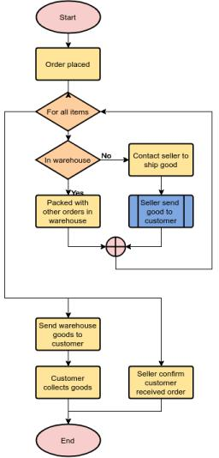

*Figure 2: Process Flow Diagram*

***In figure: 2 the actors and artefacts are described as follows:***

*A Process Flow Diagram (PFD) is a type of flowchart that illustrates the relationships between major components at an industrial plant. Using this figure I’m trying to show how the application will work and a user can visit website and how can a user order from website.*

***3.2 Data flow diagram***

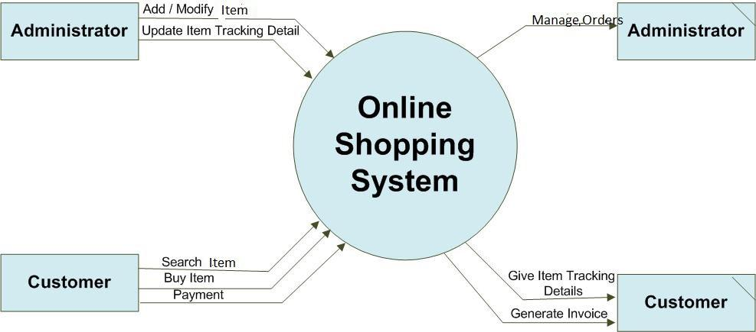

*Figure 3: Data Flow Diagram*

***In figure: 3 the actors and artefacts are described as follows:***

*A data flow diagram is a graphical view of how data is processed in a system in terms of input and output. The Data flow diagram (DFD) contains some symbol for drawing the data flow diagram. In this diagram I’m trying to show the work process of application.*

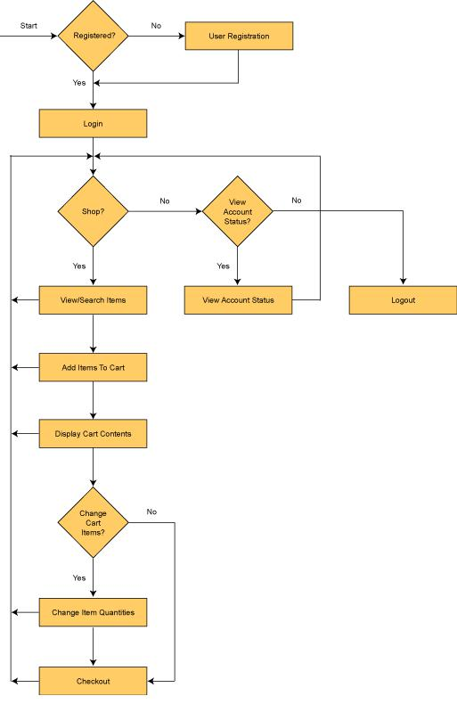***3.3 Flow chart diagram***

*Figure 4: Customer shopping flow chat*

***In figure: 4 the actors and artefacts are described as follows:***

*In this I’m trying to the how a user can use application, first user have to sign up/sign in then the user can access full application and order something from the website.*

***3.4 UML diagram***

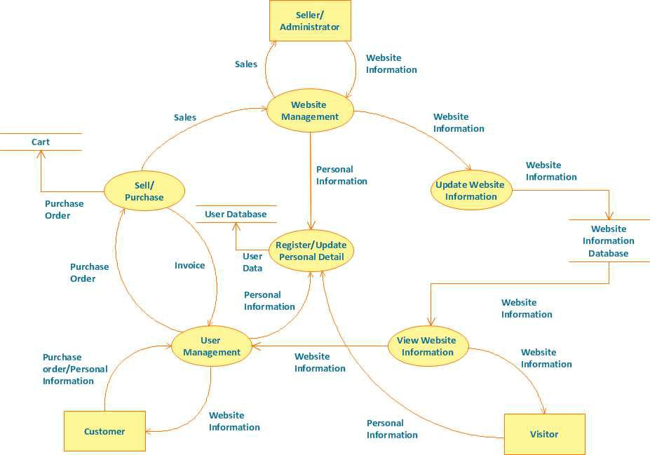

*Figure 5 : UML Diagram*

***In figure: 5 the actors and artefacts are described as follows:***

*Web User – There is web for Admin, it has three attributes Login id, Password and status. Status to know whether admin is active or not .Customer – there is customer, it has four attributes Login id, Email id, phone no and address. Account – There is account, every customer having their own account in that there is four attributes id, billing address, open_date and close_date. Shopping cart – there is shopping card for storing the product whatever customer will add in cart it has only one attribute cart created date. LineItem – There is LineItem for storing the product details whichever customer has added in cart it has two attributes quantity and price Product – There is product for storing the particular product details there is three attributes product id, product name and seller name. Order – There is order for storing the order details it has six attributes order id, order date, shipping date, shipping address, order status, total price. Payment – There is payment for storing the details of all payments it has four attributes payment id, paid date, total paid amount and details. Other status – There is other status for storing other details it has five attributes new, hold, shipped, delivered, closed. User State – There is user state for knowing the user is active or not it has four attributes new, active, blocked and banned.*

***3.5 Data design***

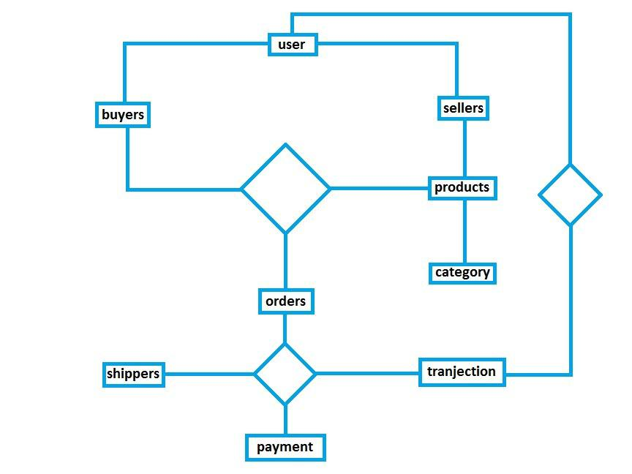

*Figure 6: Data Diagram*

***In figure: 6 the actors and artefacts are described as follows:***

*In this diagram I’m trying to show a relation between a user and a seller how a user can order something for website and how a seller can receive an order and process on the order to deliver to the customer, everything is showing in this figure.*

***3.6 Data relationship***

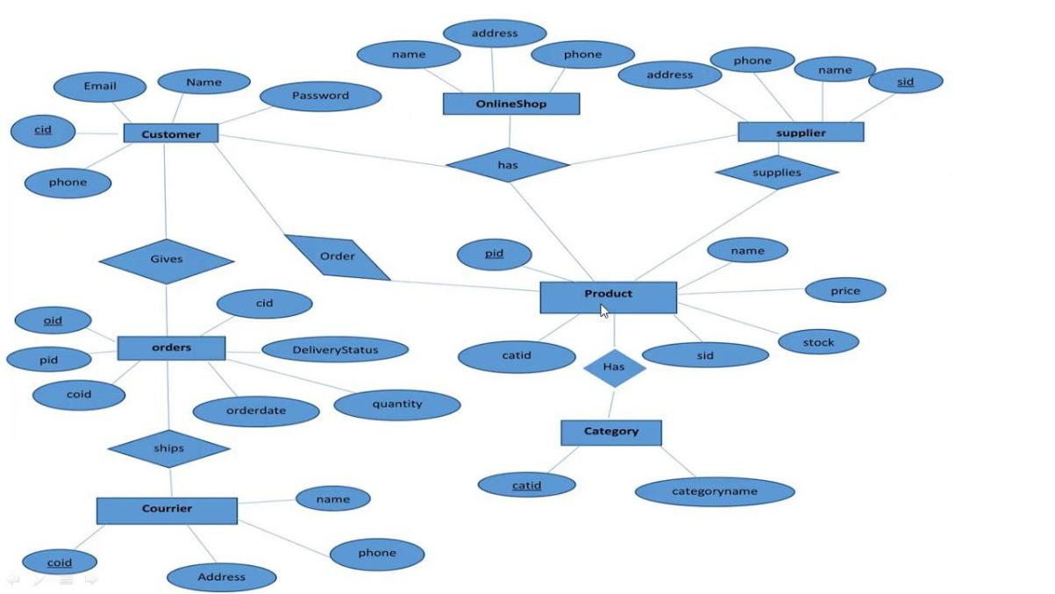

*Figure 7: Data Relationship Diagrams*

***In figure: 7 the actors and artefacts are described as follows:***

*There is Ecommerce Database, which having four rows to store all the data of our website. There is User table for store our customer and Admin details, it has seven rows to store all the details of particular person. There is Products table to store all products details, it has eleven rows to carry all the details of a particular product. There is cart table which will store cart details, it has three rows to store all details of a cart. There is Orders table to store all details of an order, it has eight rows to store all the details of any particular order.*

***Chapter 4 - Conclusion Recommendation***

***4.1 Conclusion***

*The project entitled IndiaMart Fashion Store system was completed successfully. The system has been developed with much care and free of errors and at the same time it is efficient and less time consuming. The purpose of this project was to develop a web application for purchasing items from a fashion shop. This project enabled me gain valuable information and practical knowledge on several topics like designing web pages using html & CSS, usage of responsive templates, designing of full stack IndiaMart application, and management of database using MongoDB. The entire system is secured. Also, the project helped me understanding about the development phases of a project and software development life cycle. I learned how to test different features of a project. This project has given me great satisfaction in having designed an application which can be implemented to any nearby shops or branded shops selling various kinds of products by simple modifications. However, it was very challenging learning and developing an application using a new technology.*

***4.2 Recommendation***

*There is a scope for further development in our project to a great extent. A number of features can be added to this system in future like providing. The feature like adding an authenticated payment system using Mpesa which is widely used in Kenya. Another feature we wished to implement was providing classes for customers so that different offers can be given to each class. System may keep track of history of purchases of each customer and provide suggestions based on their history using Machine Learning Algorithm. These features could have been implemented if time and skills did not limit me.*

***4.3 Record of all procedure***

|  |  |
| --- | --- |
| *Registration -* | *This procedure allows the customers to sign in before making an order. Managers of the website is created by system admin.* |
| *Product -* | *This module contains the details of all products in the store.* |
| *Price -* | *Manages Prices of products* |
| *Shopping -* | *Manages the basic flow of orders. It’s the procedure by which a client places an order* |
| *Payment -* | *Customer makes payment at this stage. However, this system does not have a real payment system.* |
| *Search -* | *Customers are able to search for specific product through this procedure* |
| *Layout -* | *Customers view products from the homepage. They can Mouse over to display product description.* |
| *Reporting -* | *The customers are able to view and download their invoices. The system also provides room form customer feedback* |
| *Administration -* | *The system admin / business managers access the admin dashboard that allows them to add products, view and confirm orders.* |
|  |  |
|  |  |

***4.4 structure of the project file***

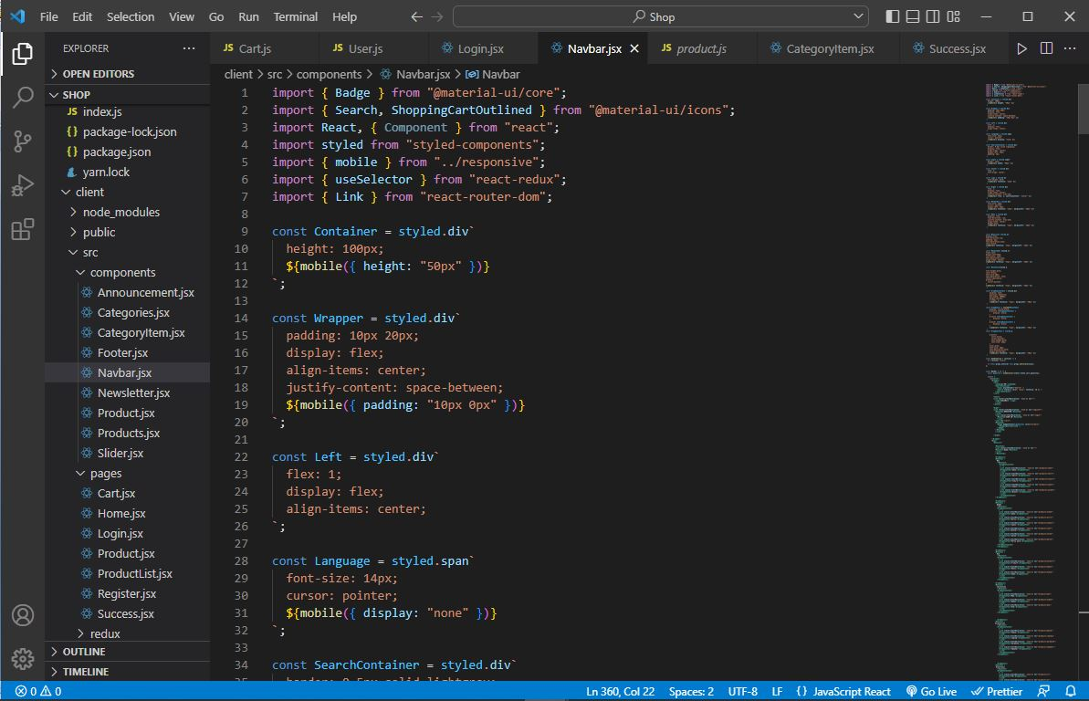

***References***

[*https://www.youtube.com/watch?v=lI1ae4REbFM&ab_channel=CleverProgrammer*](https://www.youtube.com/watch?v=lI1ae4REbFM&ab_channel=CleverProgrammer)

[*https://www.youtube.com/playlist?list=PLC3y8-rFHvwhco_O8PS1iS9xRrdVTvSIz*](https://www.youtube.com/playlist?list=PLC3y8-rFHvwhco_O8PS1iS9xRrdVTvSIz)

[*https://www.youtube.com/watch?v=1r-F3FIONl8&ab_channel=WebDevSimplified*](https://www.youtube.com/watch?v=1r-F3FIONl8&ab_channel=WebDevSimplified)

[*https://creately.com/blog/diagrams/uml-diagram-types-examples/*](https://creately.com/blog/diagrams/uml-diagram-types-examples/)

[*https://www.slideshare.net/sohelhoo/ecommerce-documentation?from_action=save*](https://www.slideshare.net/sohelhoo/ecommerce-documentation?from_action=save)